PRACTICE No.1

|  |  |  |  |
| --- | --- | --- | --- |
| **Unit: 1** | **Major:** | **Group:** | **Grade:** |

**.**

|  |
| --- |
| Practice’s name: **What do you do? VS what are you doing?** |
| Practice’s number: **1.1** |
| Topic: **Present Simple vs Present Continuous** |
| Student’s name: Giovanna Periañez Gabriel. |
| Teacher’s name: jose merchan |
| Practice’s objective: **To identify and recognize the vocabulary and structure related to simple present and present continuous.** |

**Instructions:**

1. Choose four links, two of each tense and answer the activities. The activities are related to vocabulary, and use about simple present and present continuous.
2. You should answer each activity on-line, when you finish each activity, please click on **TERMINADO**. Then, choose the option **COMPROBAR MIS RESPUESTAS**. You will get a note. You have to get screenshots of your notes.

Example: 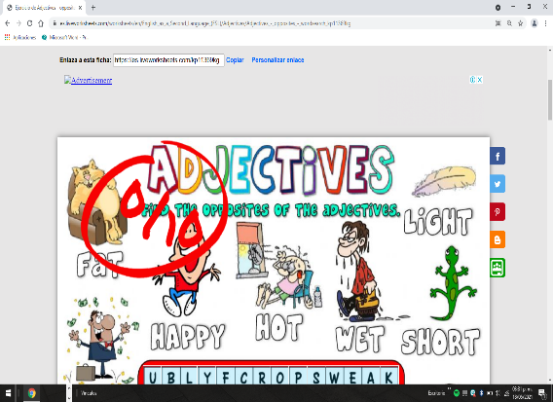

1. Finally, paste your screenshots in a document and upload it to Moodle.

**NOTE:** You’ve got to paste ALL the screenshots of the activities in this same document and send it in a PDF file in order to be graded, if it is not in the asked format it is not going to be taken into account for a grade.

|  |  |
| --- | --- |
| **ACTIVITIES** | **LINKS** |
| Simple Present | <https://es.liveworksheets.com/worksheets/en/English_as_a_Second_Language_(ESL)/Present_Simple/Present_Simple_hr39728hk>  <https://es.liveworksheets.com/worksheets/en/English_as_a_Second_Language_(ESL)/Present_Simple/Present_Simple,_affirmative_and_negative_sentences_and_questions_to1253224mh>  <https://es.liveworksheets.com/worksheets/en/English_as_a_Second_Language_(ESL)/Present_Simple/Emma's_daily_routine_-_reading_gs10686ib>  <https://es.liveworksheets.com/worksheets/en/English_as_a_Second_Language_(ESL)/Present_Simple/Simple_Present_Exercises_qt22073qp> |
| Present Continuous | <https://es.liveworksheets.com/tr1305266bc>  <https://es.liveworksheets.com/worksheets/en/English_as_a_Second_Language_(ESL)/Present_simple_and_present_continuous/Present_Simple_vs_Present_Continuous_dn908913vs>  <https://es.liveworksheets.com/worksheets/en/English_as_a_Second_Language_(ESL)/Prepositions_of_place/Reading_comprehension._My_bedroom_qk766246pg>  <https://es.liveworksheets.com/worksheets/en/English_as_a_Second_Language_(ESL)/Present_simple_and_present_continuous/Reading_-_Eating_around_the_world_cz1286877ph> |

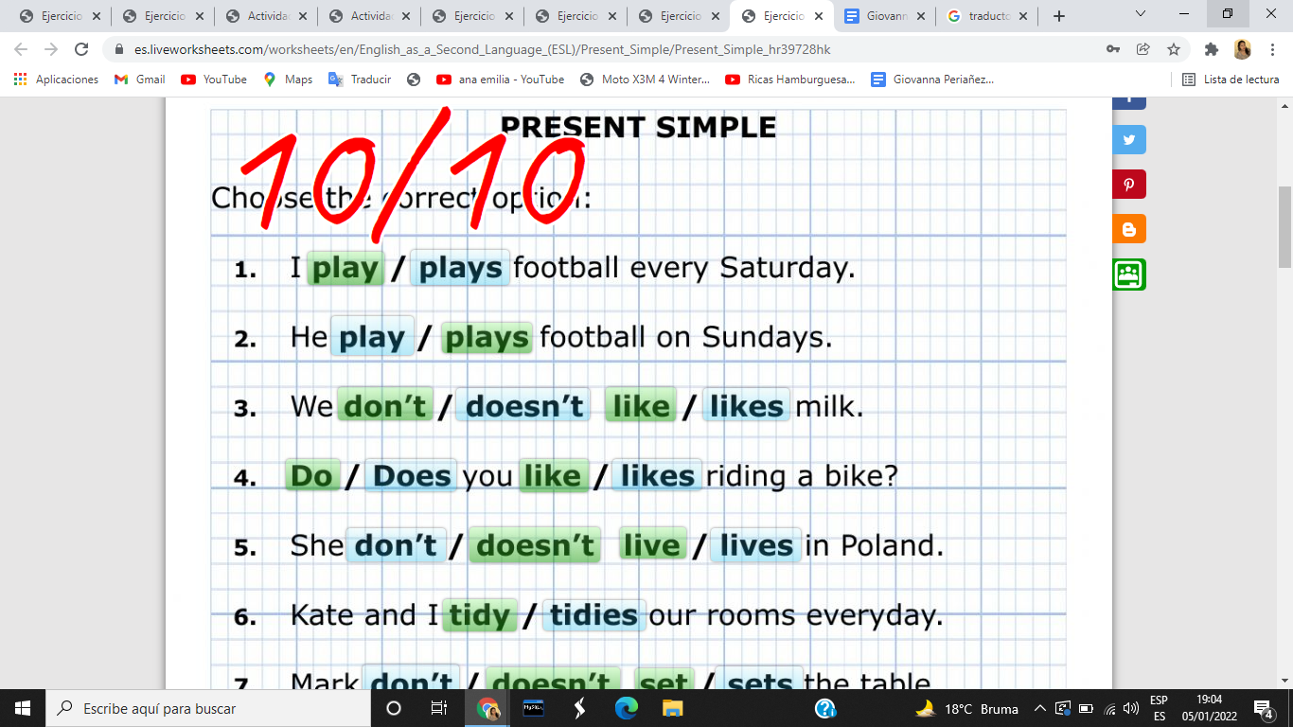

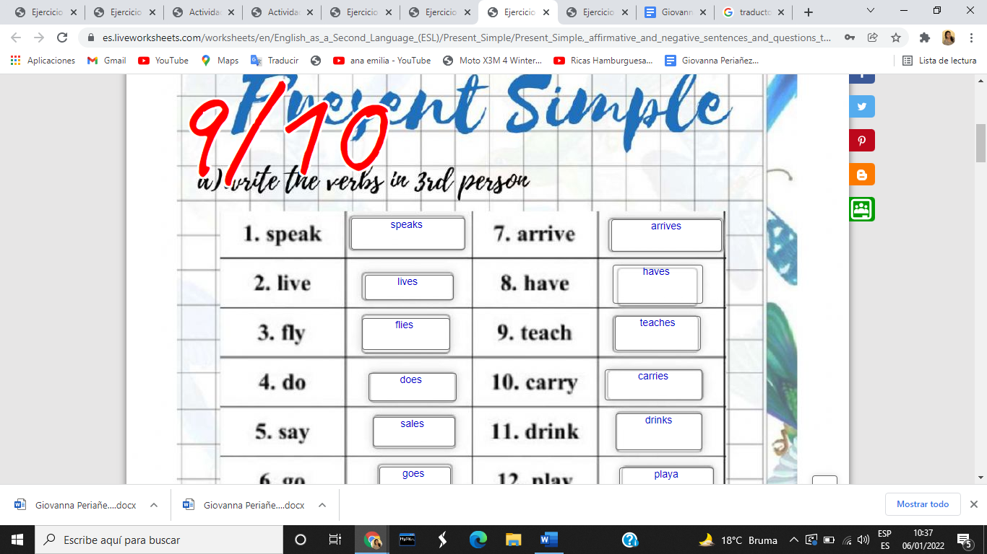

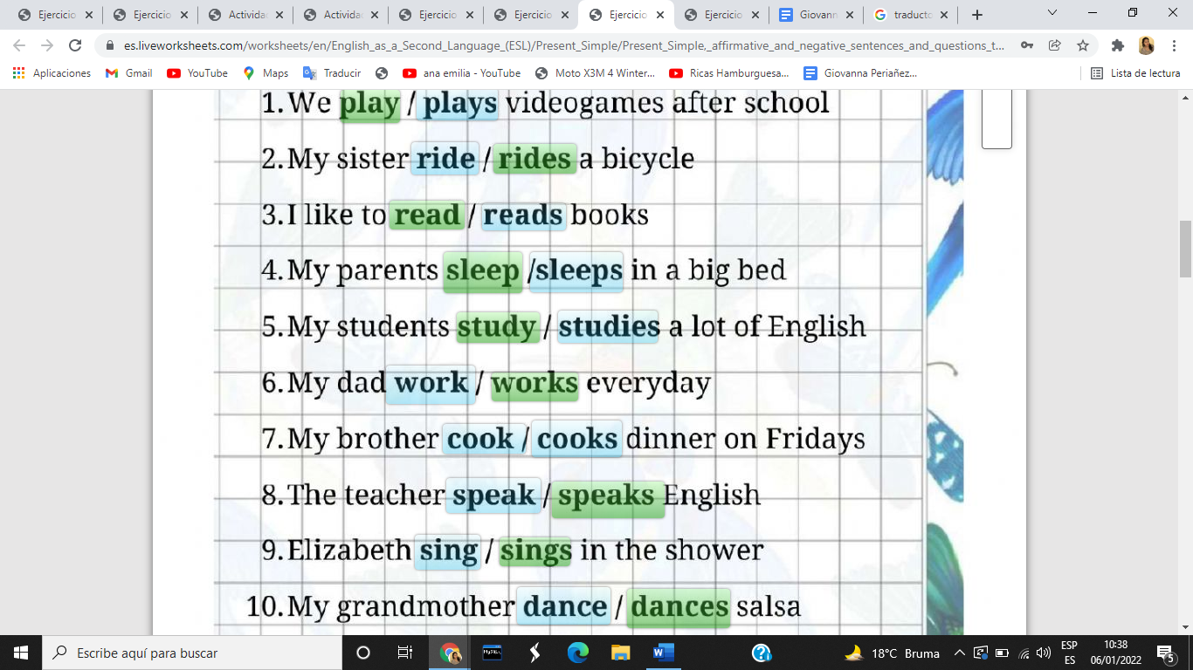

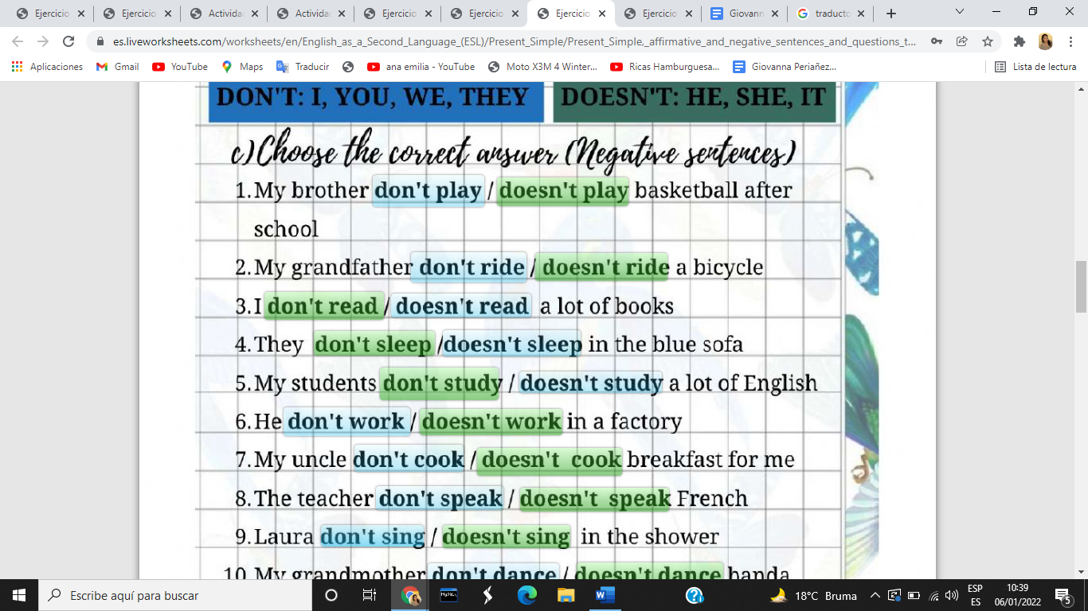

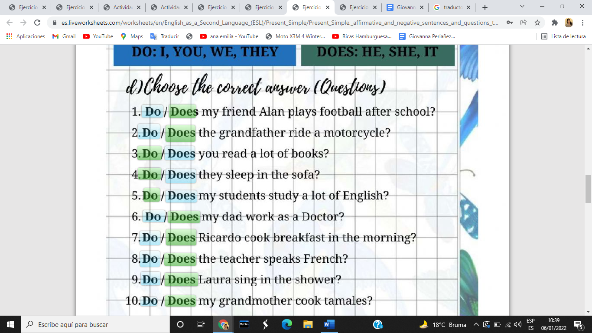

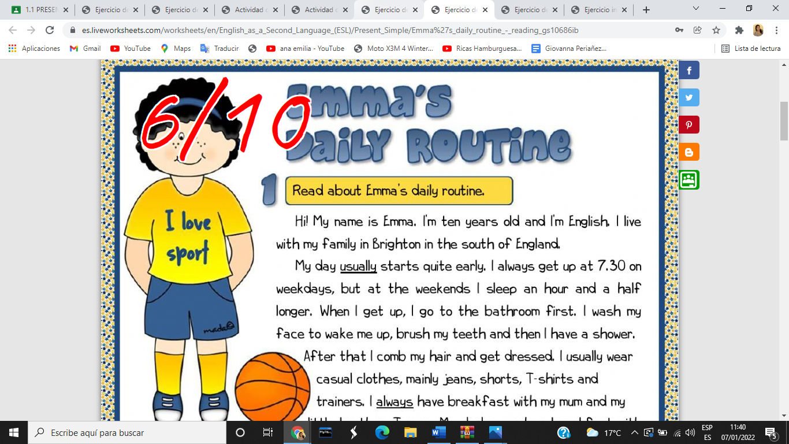

Present Continuous 1.1

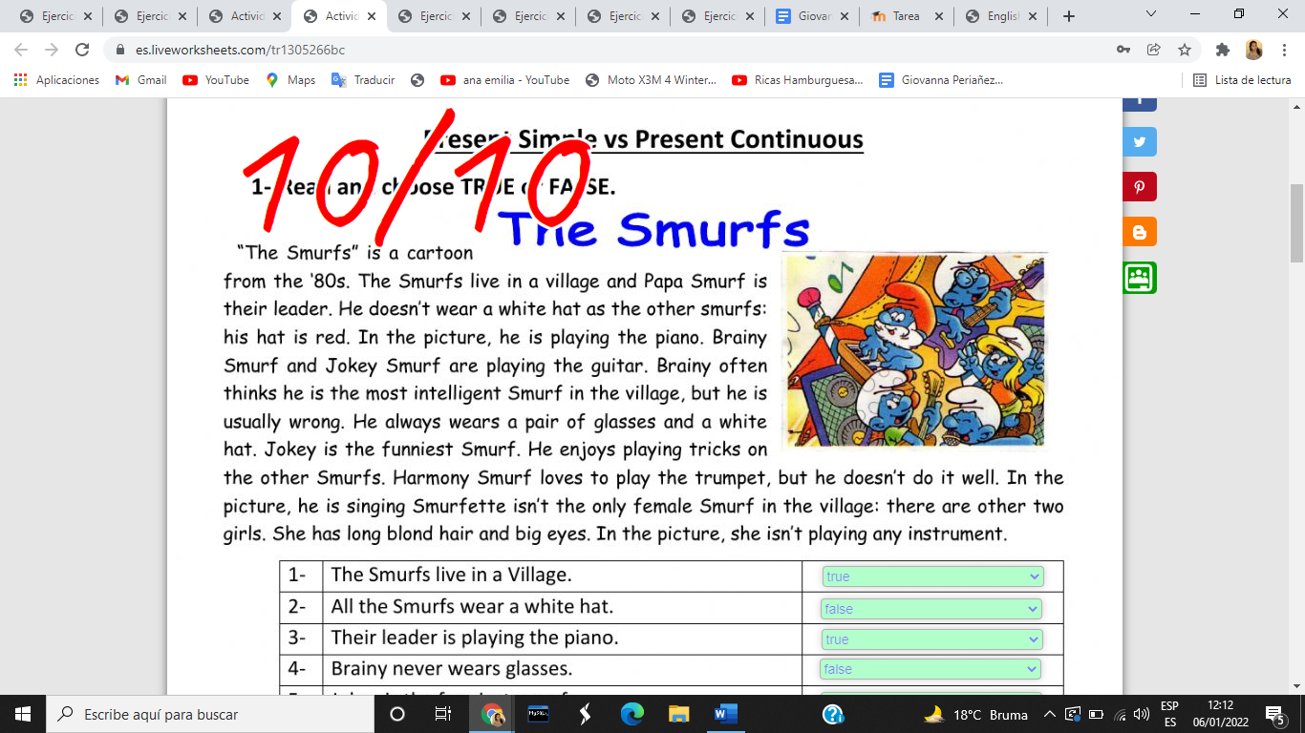

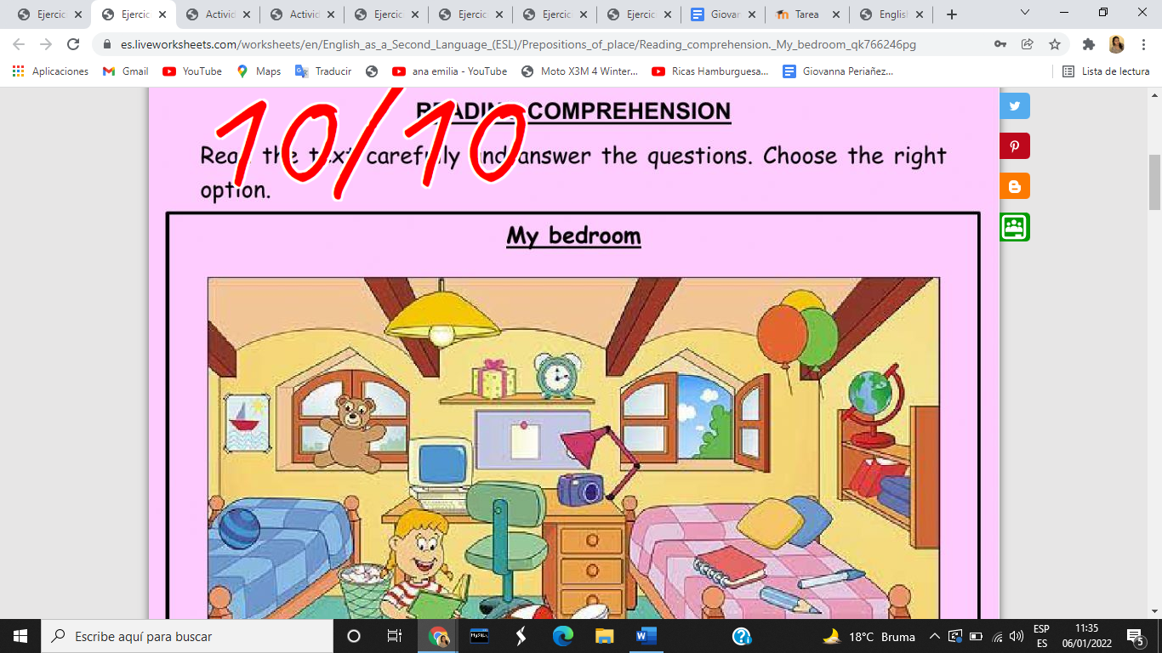

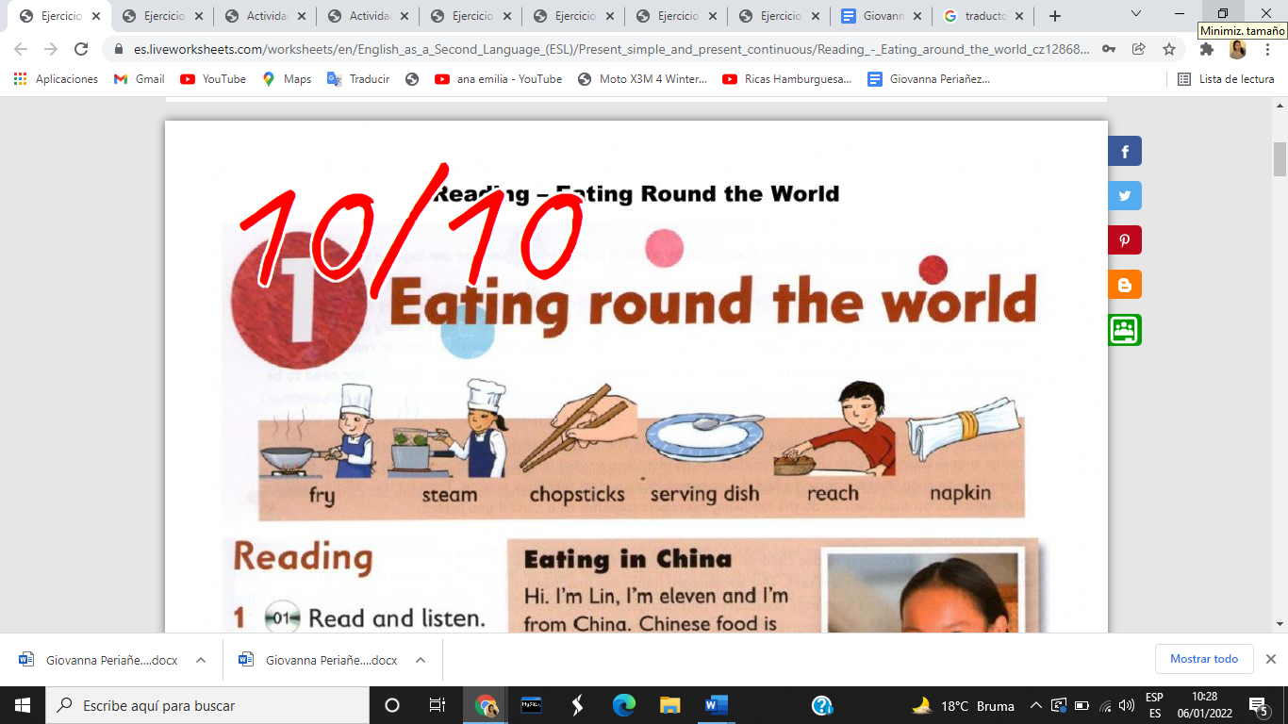

1.2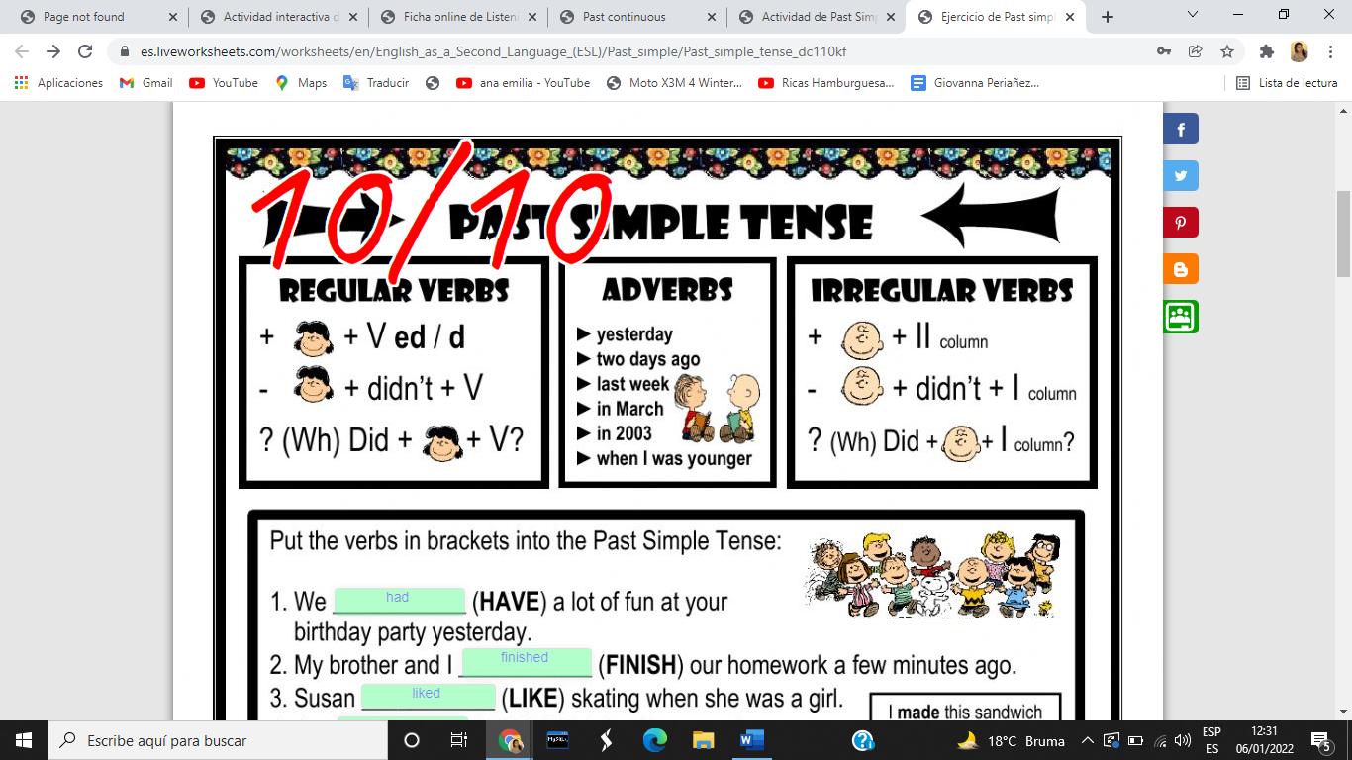

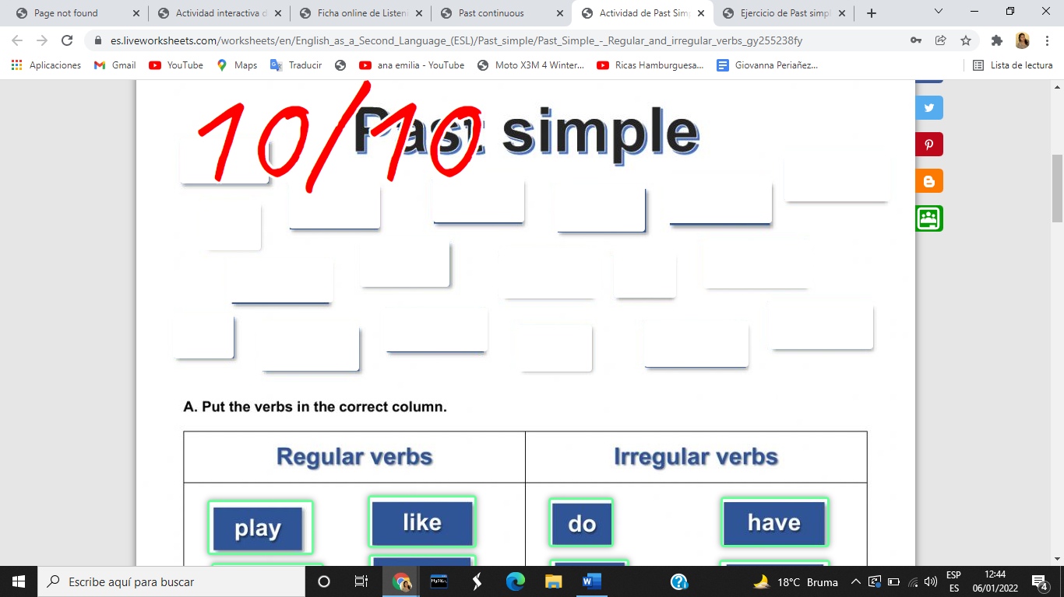

Past Continuous

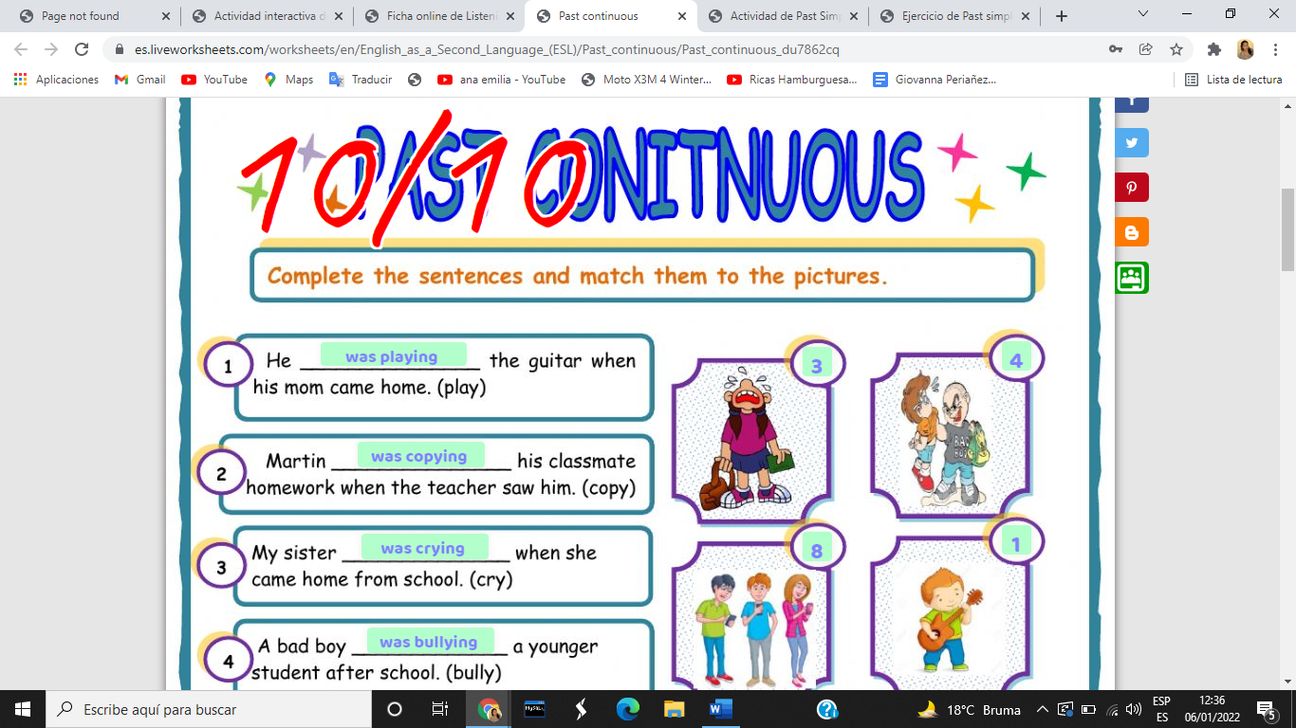

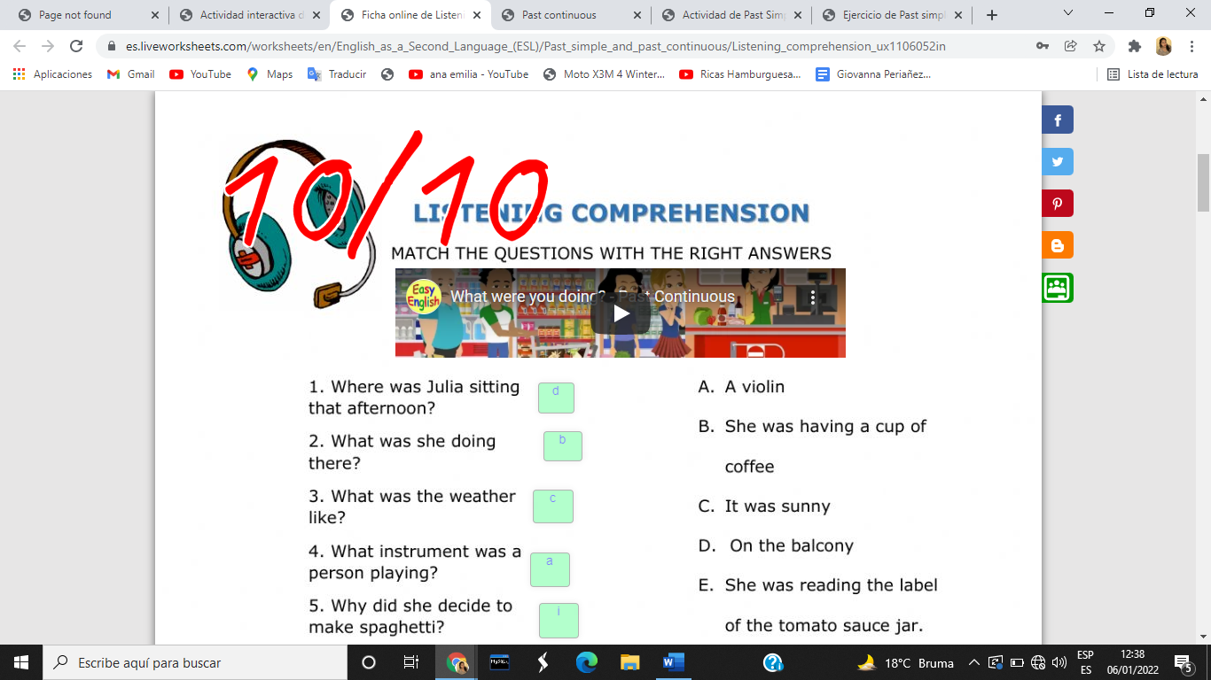

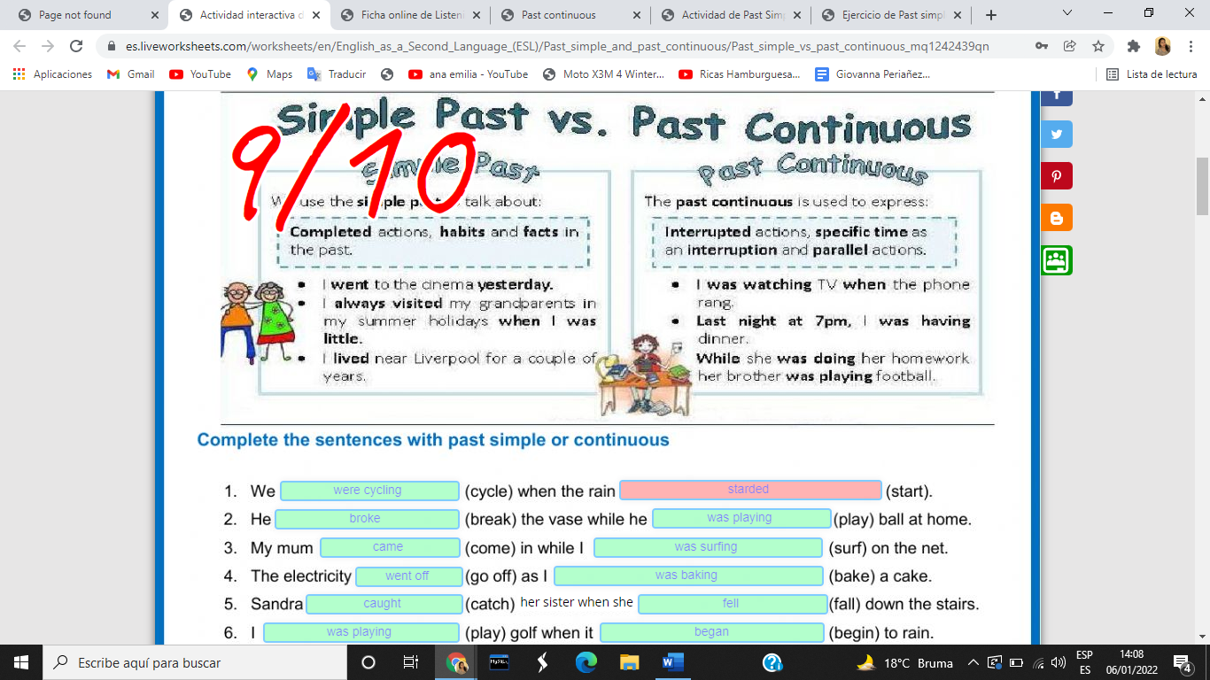

Esta no me dejó abrir

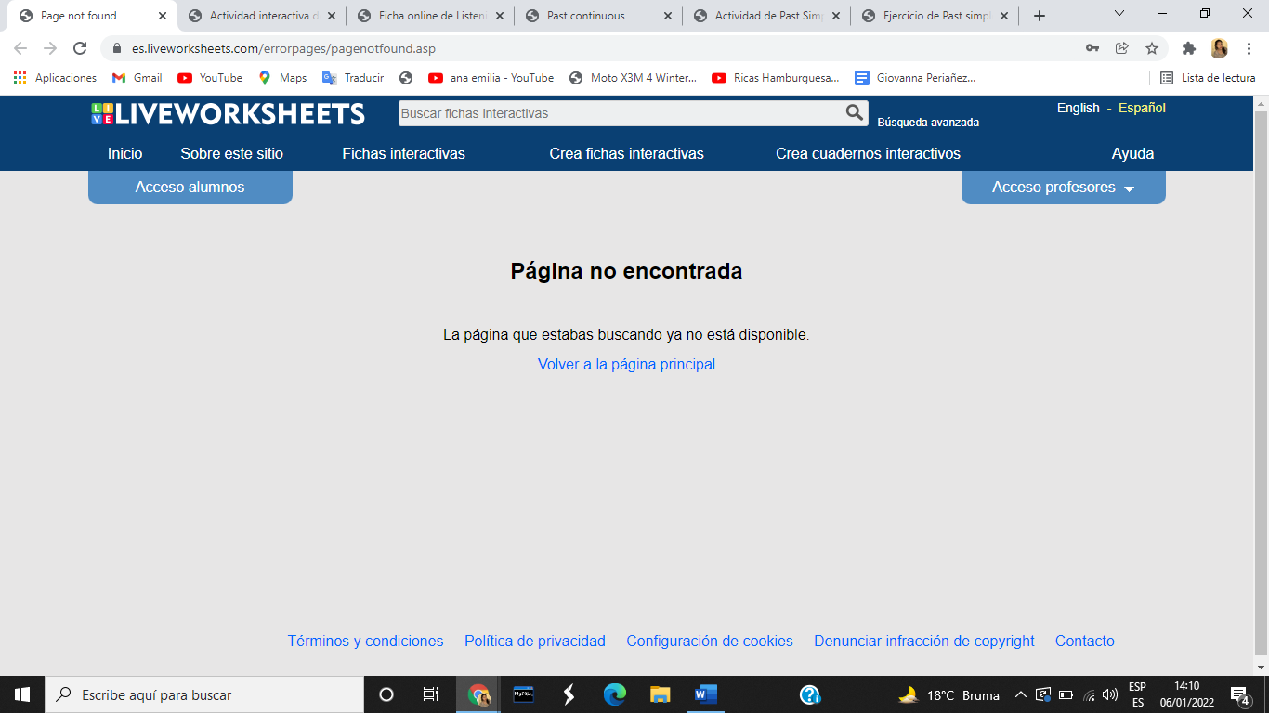

1.3

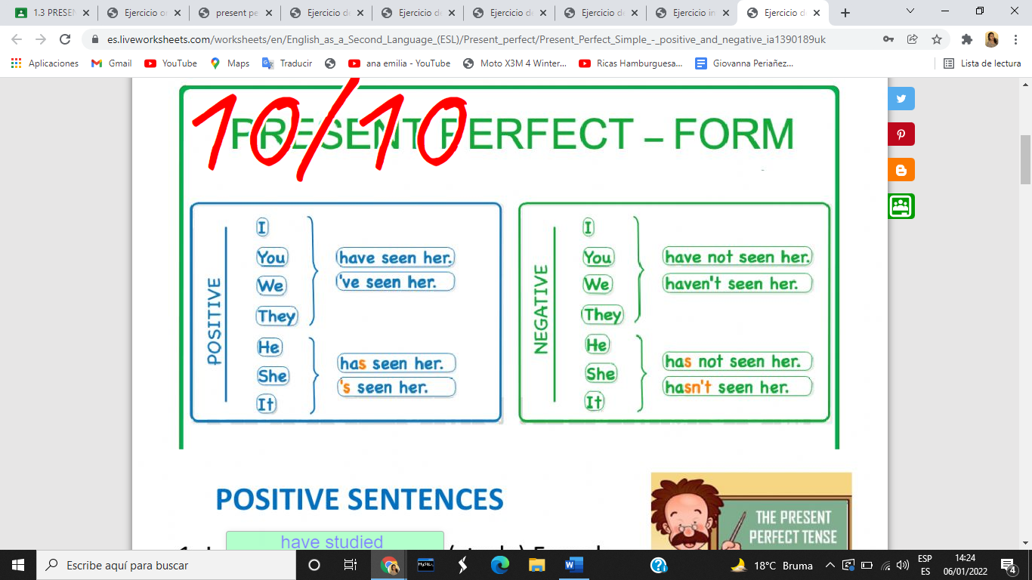

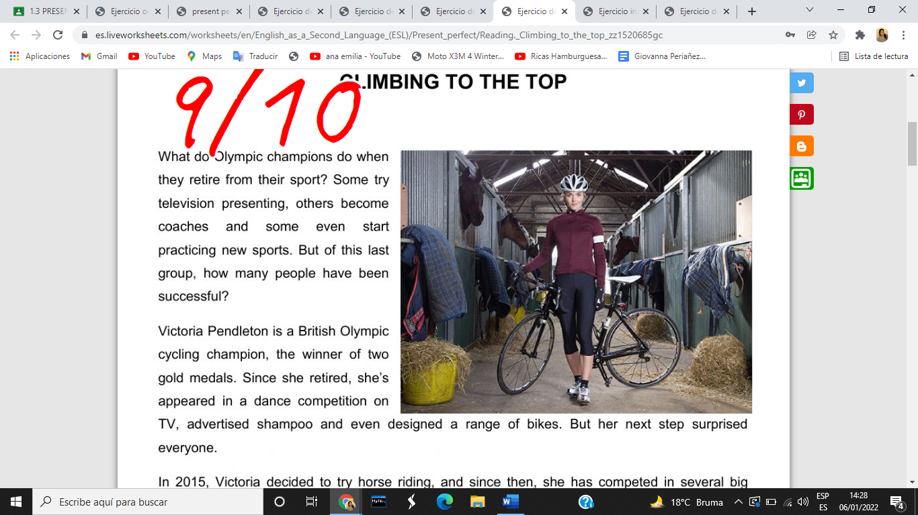

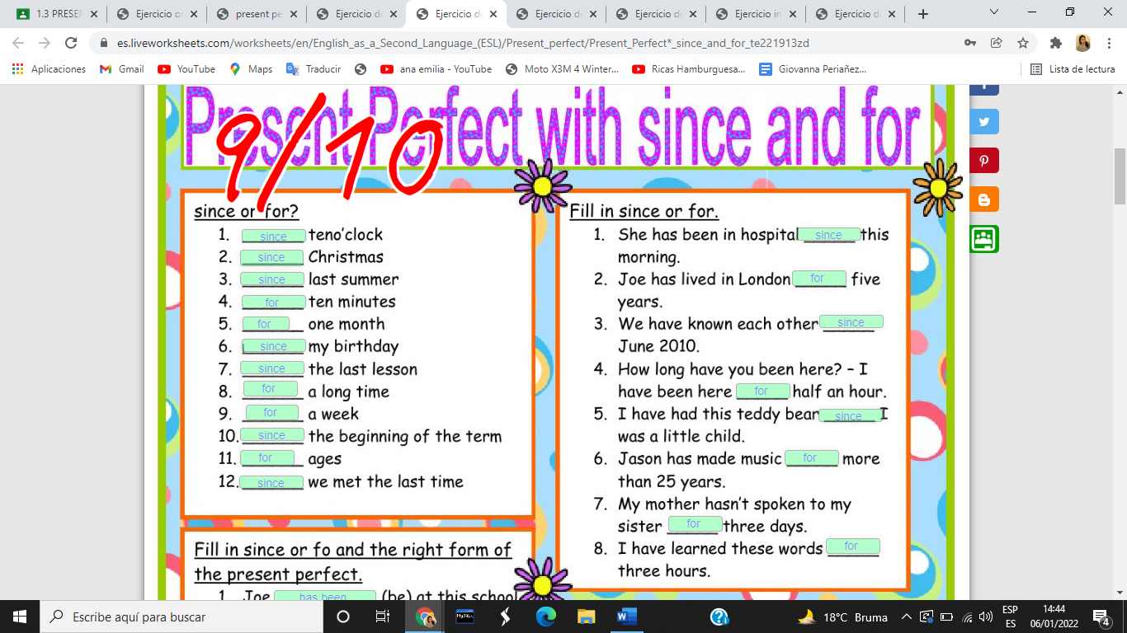

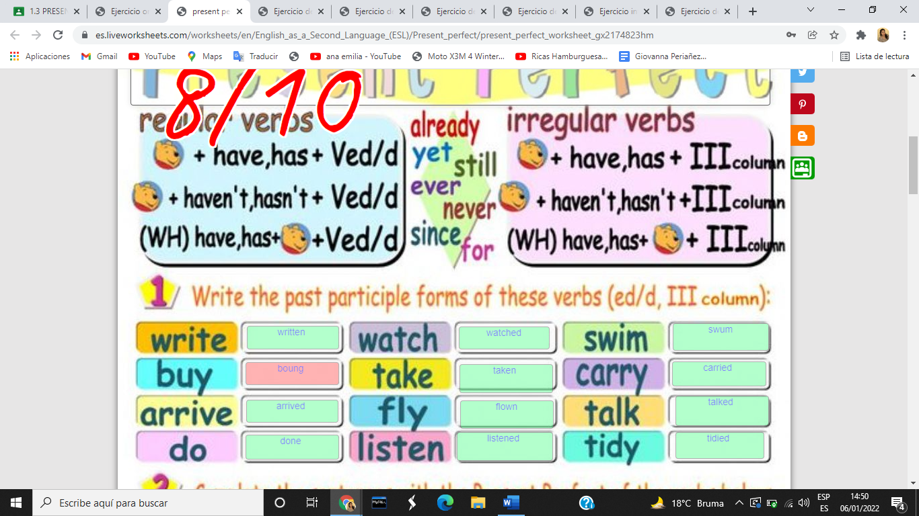

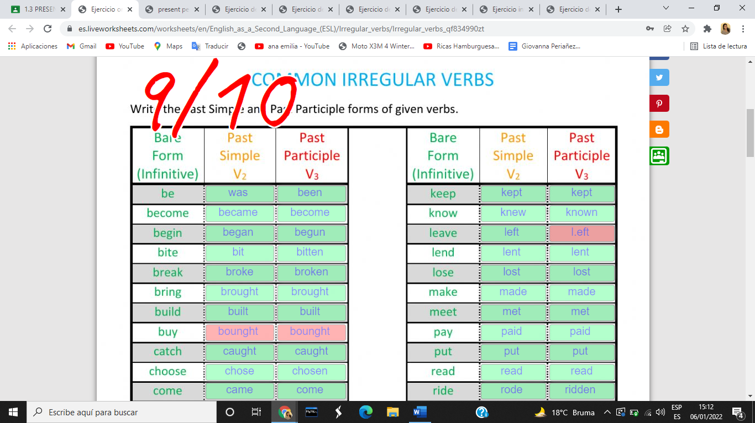

1.4